Mathematics Methods Unit 4


Investigation 2: The usefulness of logarithms

Name: ____________________
Validation: Week 17 Thursday 7th of June

- The Out of Class Investigation is designed for you to learn the essentials needed for the In-Class validation.
- This is the “Take Home” part of the Investigation. It does not count towards your mark for this investigation.

The following chart shows the loudness levels, some of which can damage the human ear.
Chart of sound intensity levels (loudness)for environmental noise
 | Weakest sound heard | 0 dB
 | Rustling leaves | 10 dB
 | A whisper in library at 2 m | 30 dB
 | Converation at home | 50 dB
 | Conversation in restaurant | 60 dB
 | Passenger car at 80 kph at 6 m | 70 dB
 | Vacuum cleaner at 1m | 70 dB
 | Freeway at 20 m | 73 dB
 | Telephone dial tone | 80 dB
At 90 - 95 dB sustained exposure may sustain hearing loss | Car wash at 6 m | 90 dB
 | Train whistle at 150 m | 90 dB
 | Hand drill | 98 dB
 | Lawn mower at 1M | 105 dB
 | Motorbike | 100 dB
 | Jet take off at 300 m | 100 dB
 | Sand blasting | 115 dB
Threshold of discomfort | Thunderclap | 120 dB
 | Chain saw | 120 dB
 | Oxygen torch | 120 dB
 | Loud rock concert | 115 dB
Pain threshold 130 dB | Pneumatic riveter | 125 dB
 | Aircraft carrier deck | 140 dB
Eardrum rupture | Jet take off at 25 m | 150 dB

The reference level of the intensity of sound, I that all others are compared to is 10 ⁻¹² watts/m ². It was chosen because it is the weakest intensity of sound that can be detected by the human ear.
Intensity, I so I is measured in watts/m ².

I ₌ 10 ⁻¹² watts/m ².

The most intense sound that is not painful to humans is roughly 10 watts/m². Since the human pain threshold at 10 watts/m ² is 10,000,000,000,000 times greater than the reference level, it makes sense to use a logarithmic scale to discuss the intensity of sound, I. The sound intensity level, L, is a logarithmic measure given as

L = 10 log $\left( \frac{I}{I_{0}}\right)$ and is measured in decibels (dB).

The lowest sound heard by man is | The loudest sound heard without pain (ie. the pain threshold) is 10 watts/m².

Question 1
Show that the pain threshold is 10¹³ times more intense than the lowest sound heard by man.

Question 2
- What is the sound intensity level that corresponds to a sound that has an intensity of 10⁻² watts/m²?

- What sound could this be from the table?

Question 3
- How many times more intense is the sound of a loud rock concert than the sound of a conversation at home?
Hint : Find

b) How many times more intense is the sound of a conversation in a restaurant than the sound of a conversation at home?

Question 4
Determine the intensity in watts/m ² of the following sounds
(a) (i) a chain saw (ii) a vacuum cleaner at 1m

(iii) rustling leaves (iv) a telephone dial tone

(v) a hand drill (vi) an aircraft carrier deck

(vii) the ticking of a watch with a sound intensity level of 20 dB

b) Explain the reason for using sound intensity levels in decibels rather than intensity in watts/m ².

Question 5
Use the semi – logarithm graph paper (one axis has a logarithmic scale) to plot some of the intensities of the sounds in Question 4 against their sound intensity levels and comment on the shape of the graph.

What is the advantage of using this graph paper for the data from Question 4?

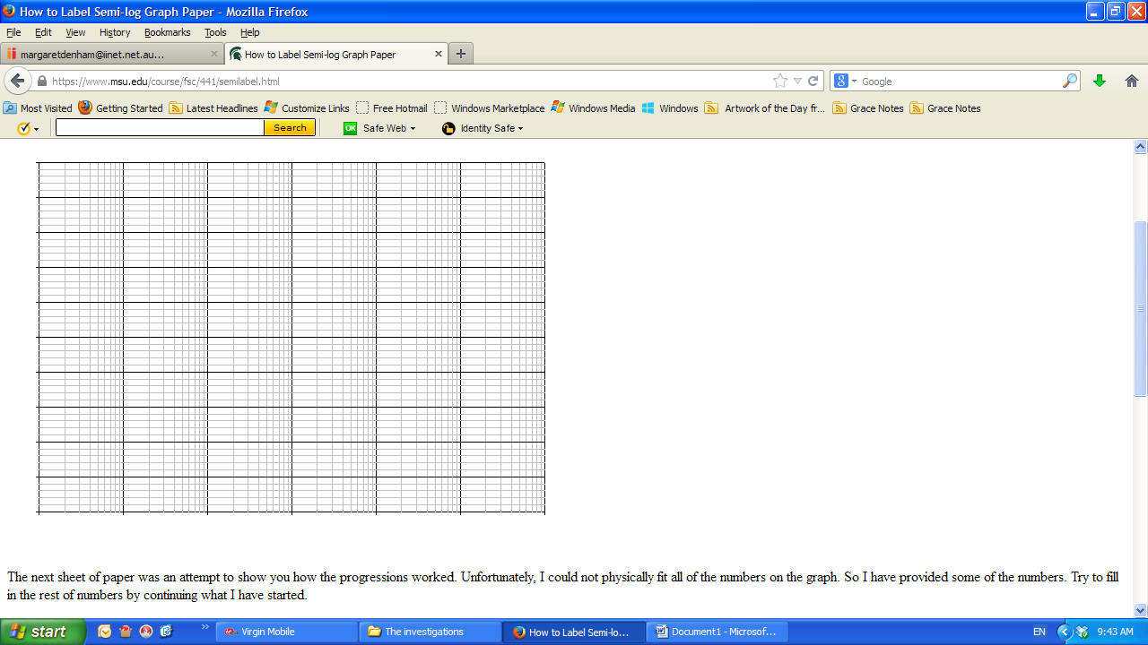
10

1

0.10000

Intensity of
sound ( I )

0.01000

0.00100

0.00010

0.00001
50 60 70 80 90 100 110 120 130
Sound intensity level (L) Decibels

Semi-logarithm graphs are useful when graphing data that increases exponentially. For example, a population of rabbits that is doubling every year.
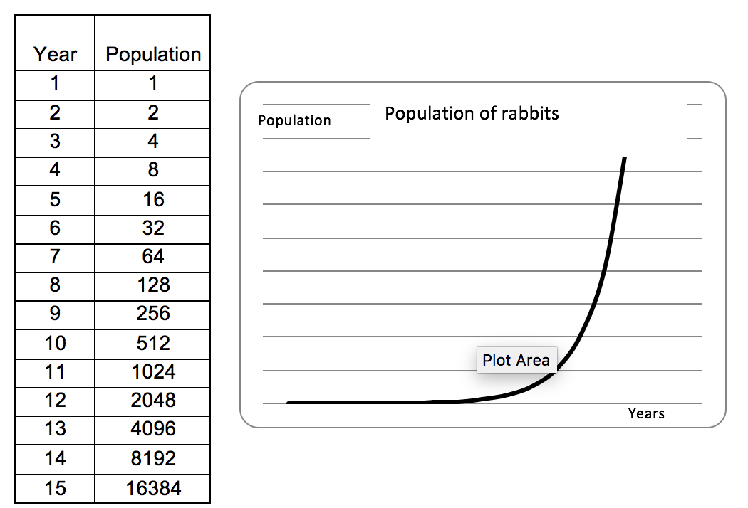
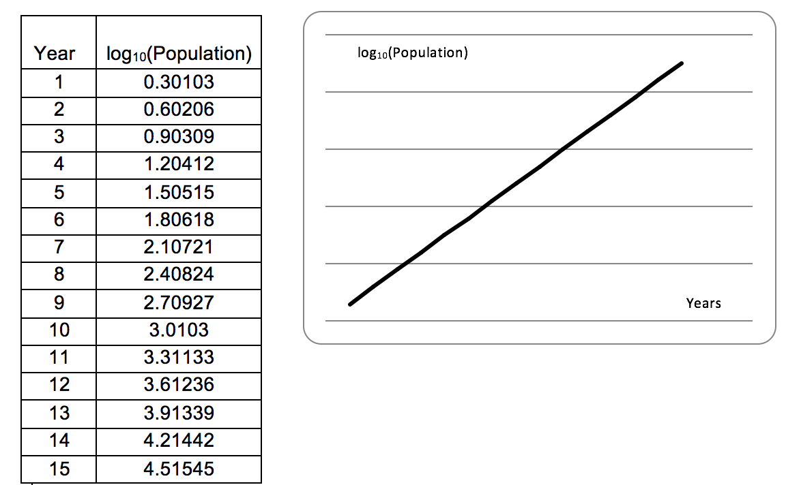

If the function is exponential, then using semi-logarithm paper makes the graph linear.

Question 6
Show that if the function is exponential, say y = A(b)^{t} then the function log_{c}(y) graphed against t is linear.

